LOAN ELIGIBILITY PREDICTION

INTRODUCTION:

OVERVIEW:

Loans are the core business of banks. The main profit comes directly from the loan’s interest. The loan companies grant a loan after an intensive process of verification and validation. However, they still don’t have assurance if the applicant is able to repay the loan with no difficulties.

Goal of this project is to automate the loan eligibility process (real time) based on customer detail provided while filling online application form. These details are Gender, Marital Status, Education, Number of Dependents, Income, Loan Amount, Credit History and others. To automate this process, a problem has been given to identify the customers segments, those who are eligible for loan amount so that they can be targeted.

PURPOSE:

The main aim of this use-case is to build a predictive model to predict if an applicant is able to repay the lending company or not.

THEORITICAL ANALYSIS:

BLOCK DIAGRAM:

INPUT DATASET

PREPROCESS THE DATA TEST DATASET

CREATE THE MODEL TRAIN THE MODEL TEST THE MODEL

REQUIREMENTS:

\* ECLIPSE  
\* WEKA  
\* LANGUAGE:JAVA

* EXPERIMENTAL INVESTIGATIONS:

DATA ANALYSIS:

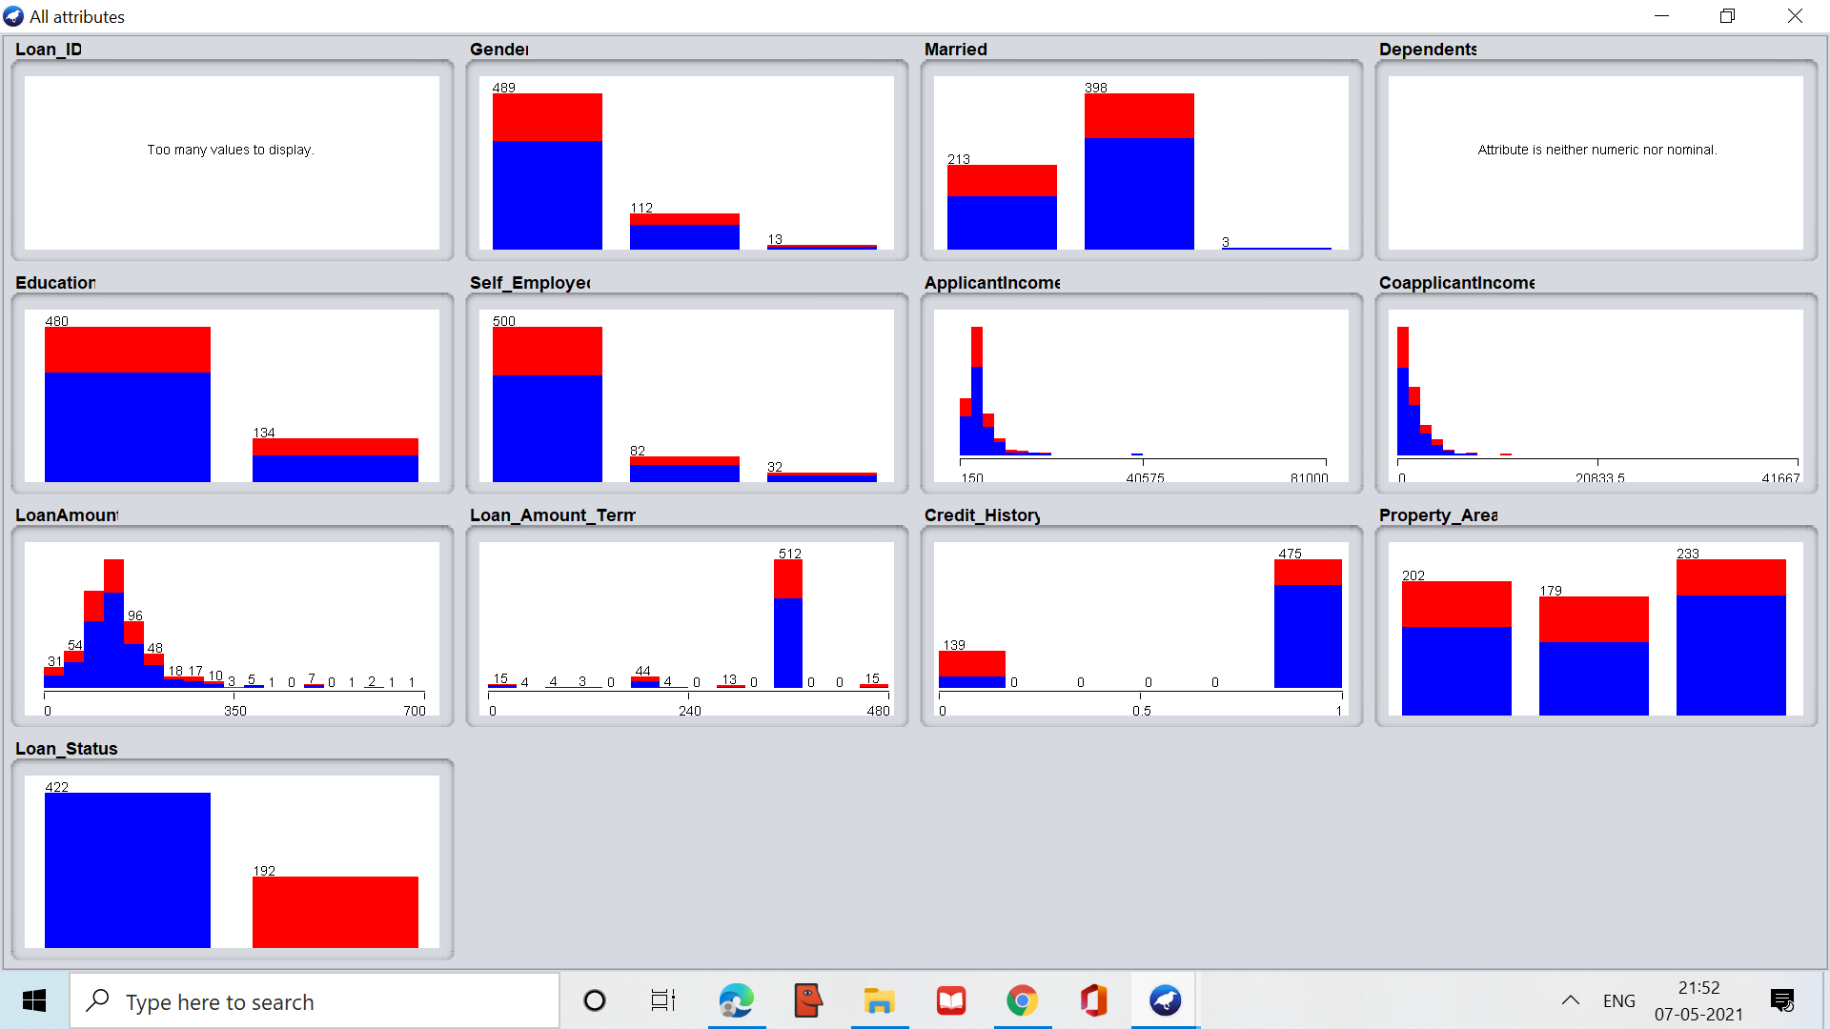

DATA PREPROCESSING:  
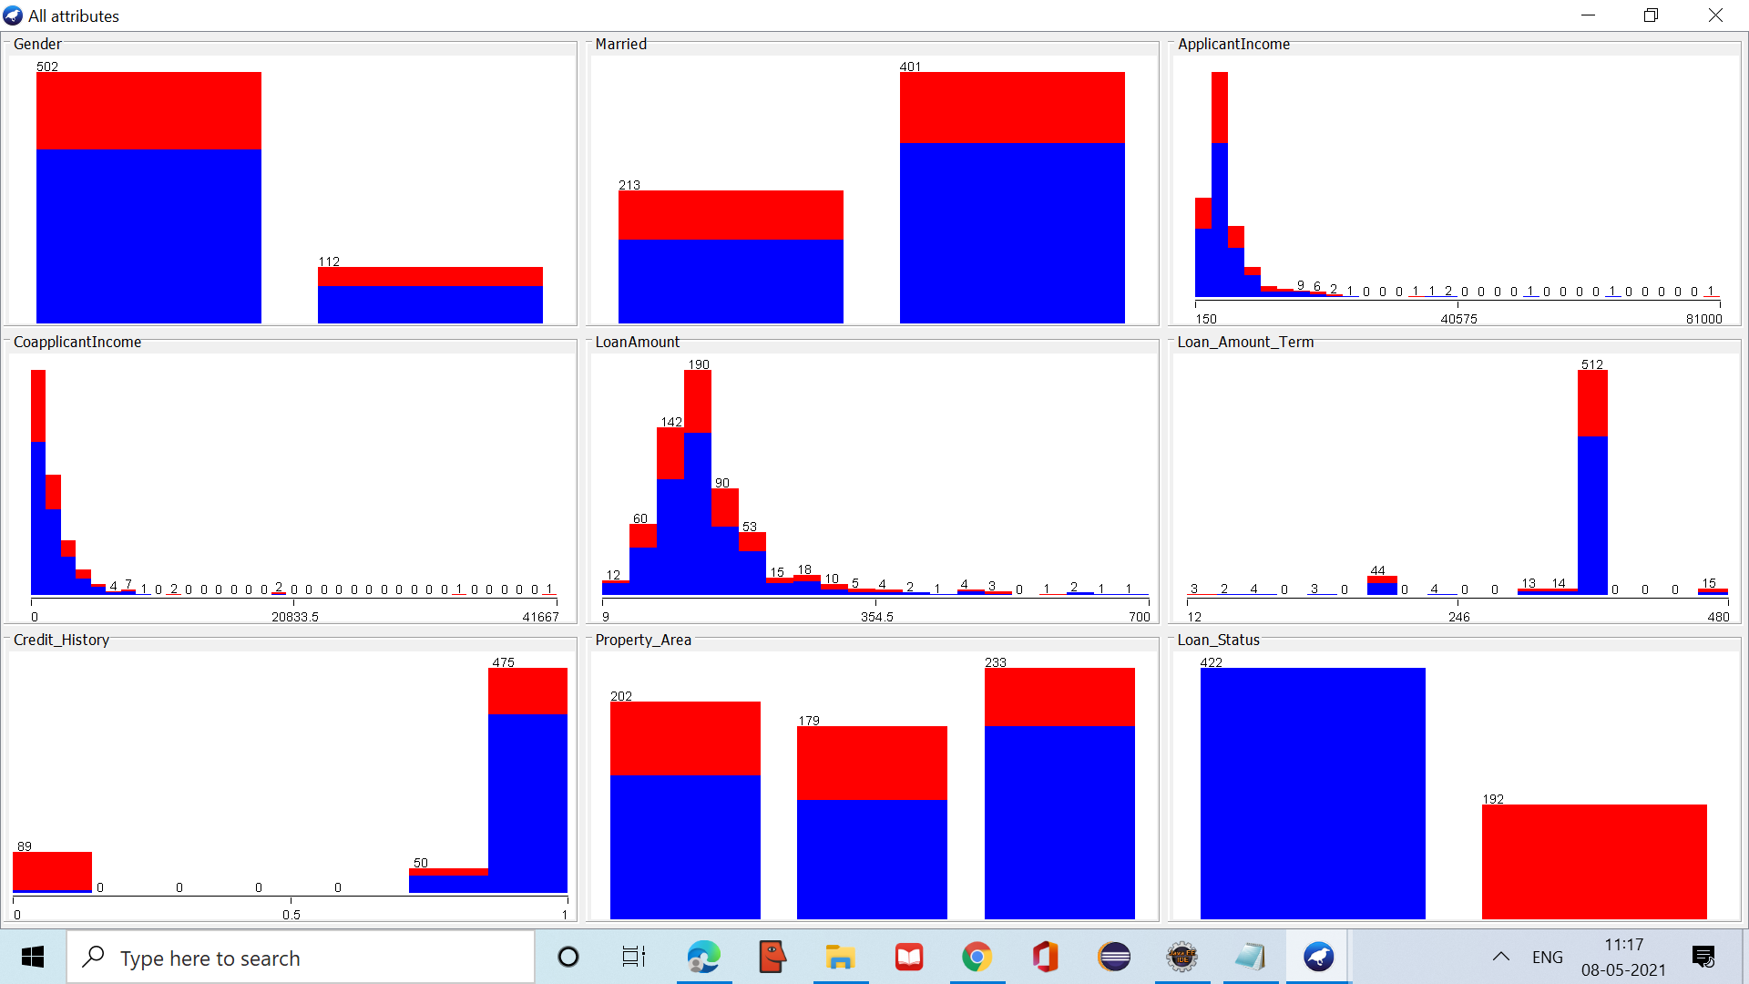

DATA VISUALIZATION:

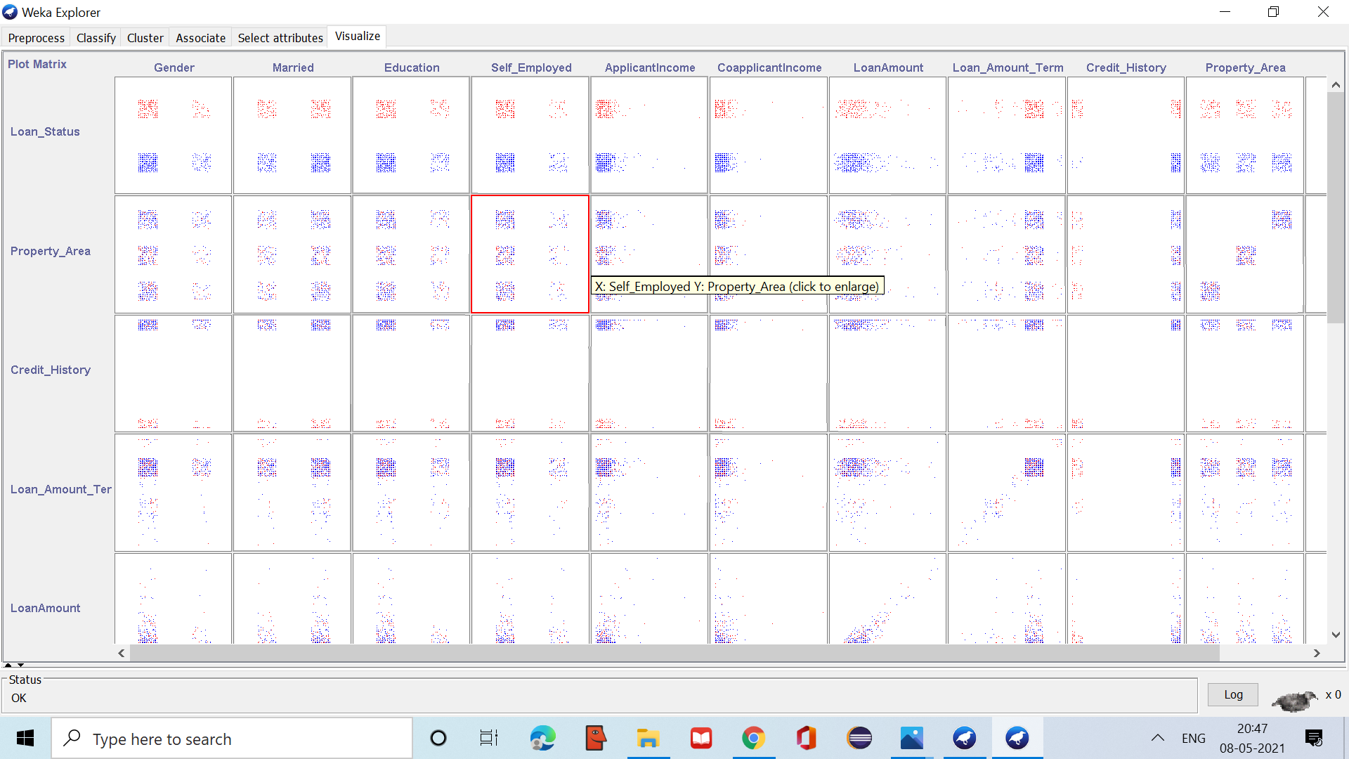

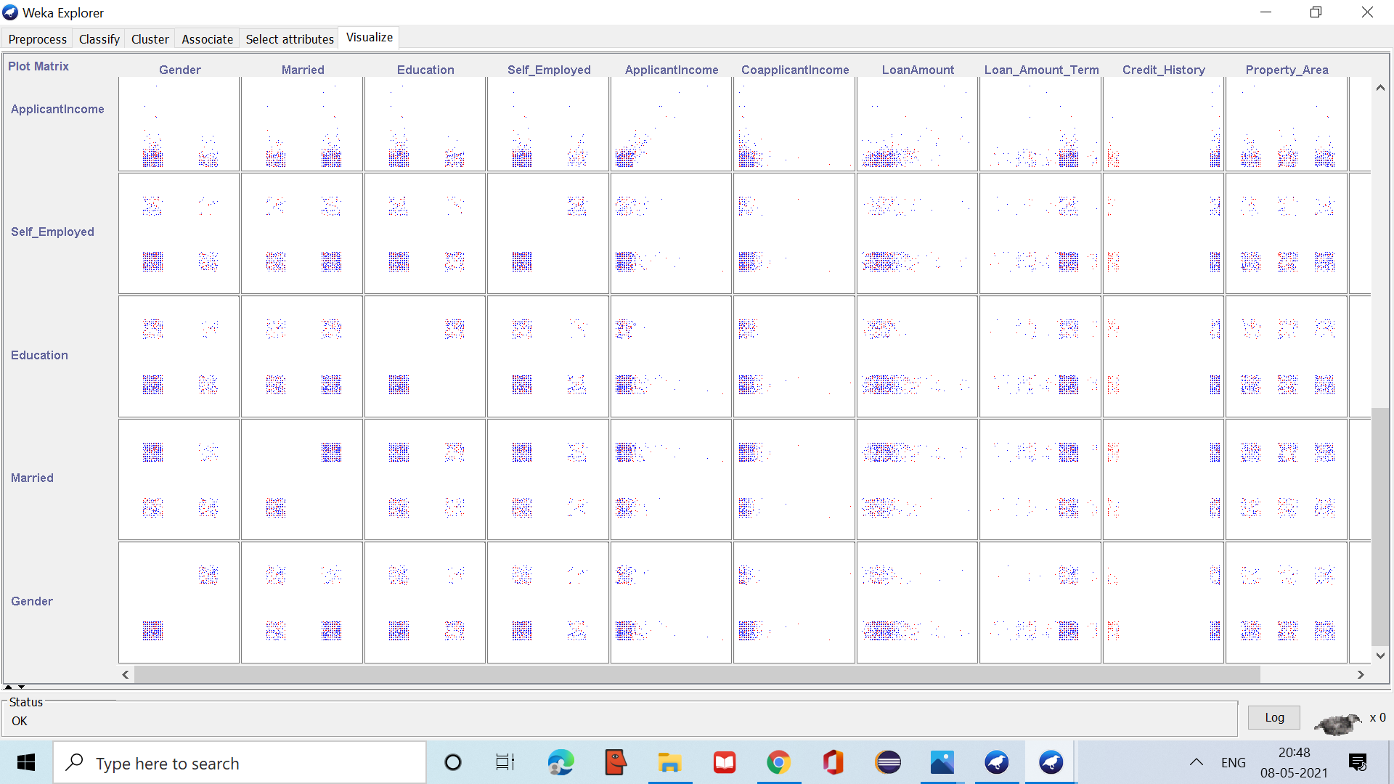

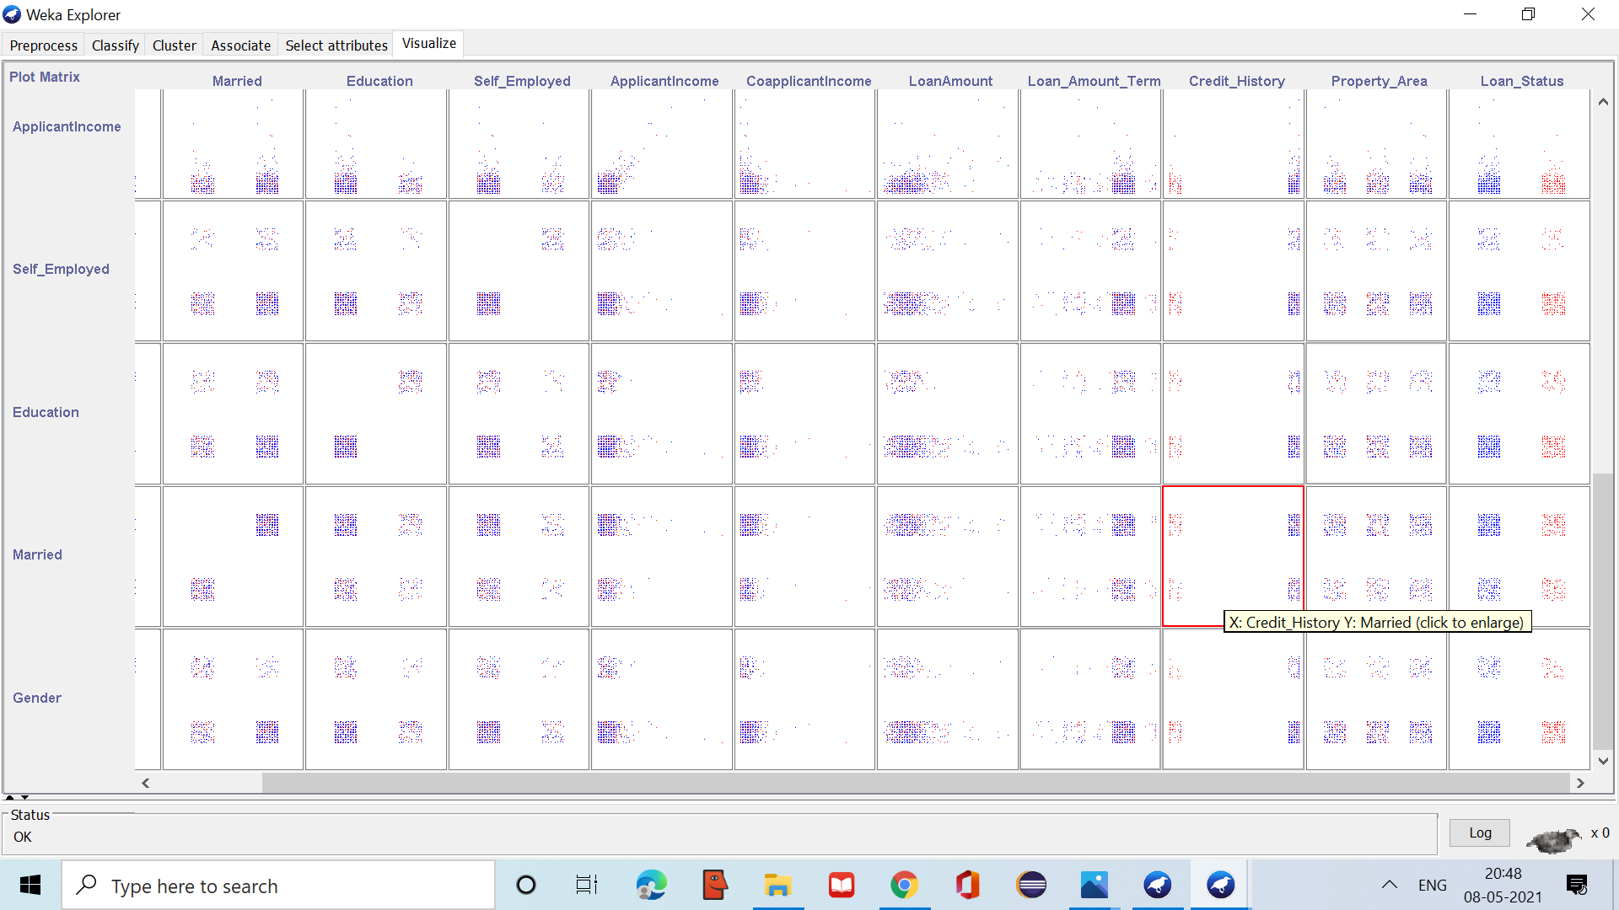

FLOW CHART:

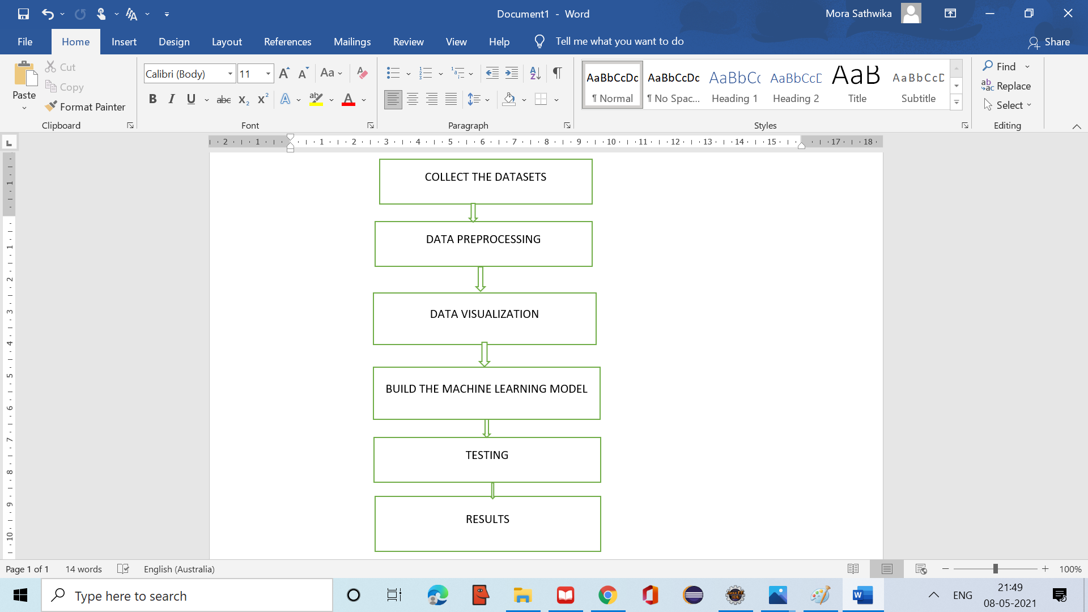

PREDICTION MODEL AND TESTING:

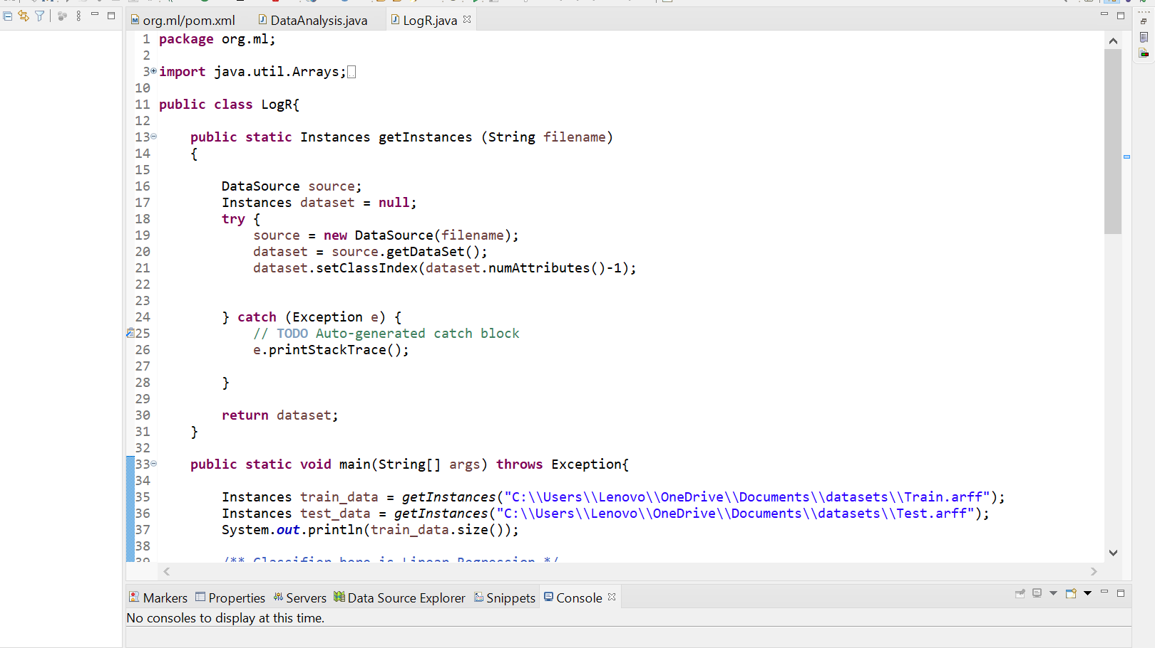

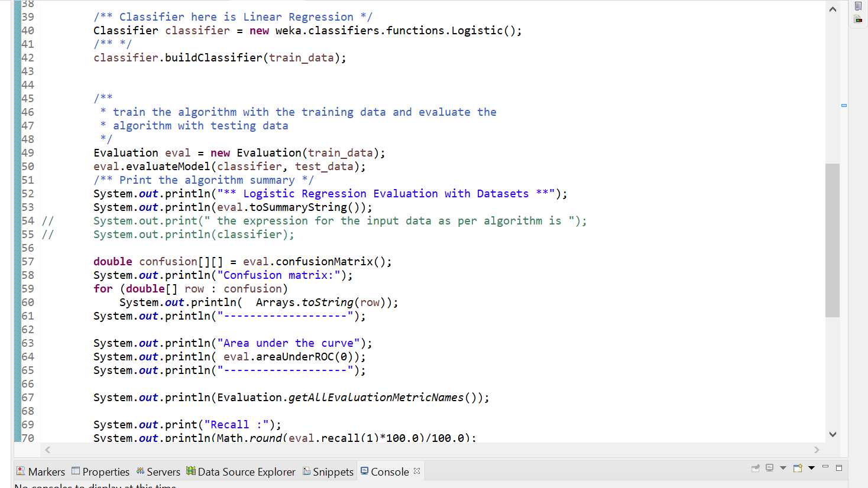

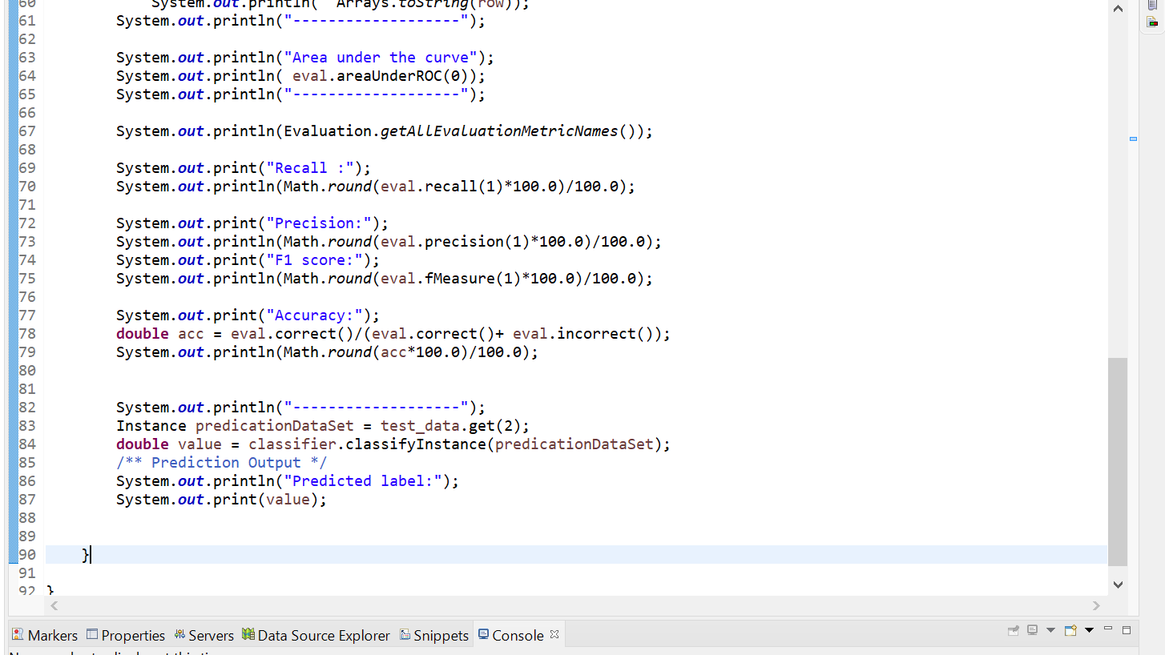

RESULTS:

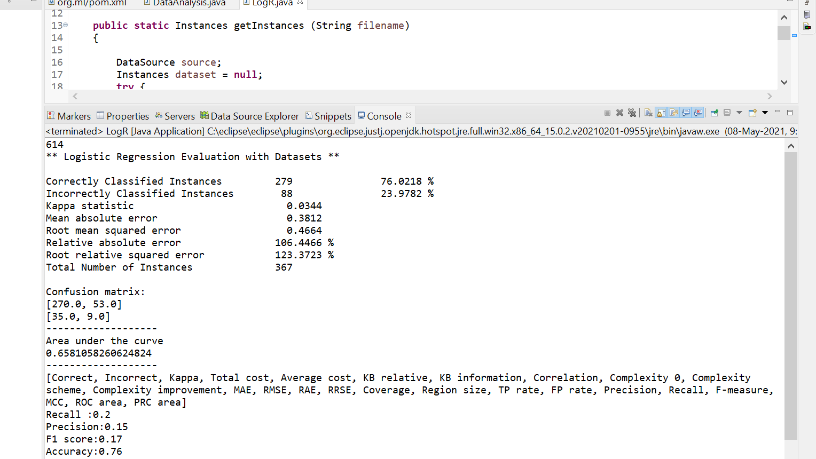

CROSS VALIDATION:

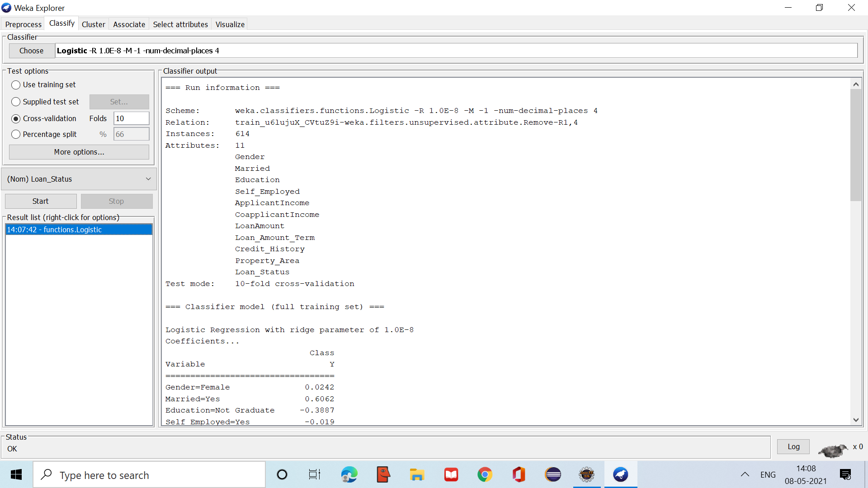

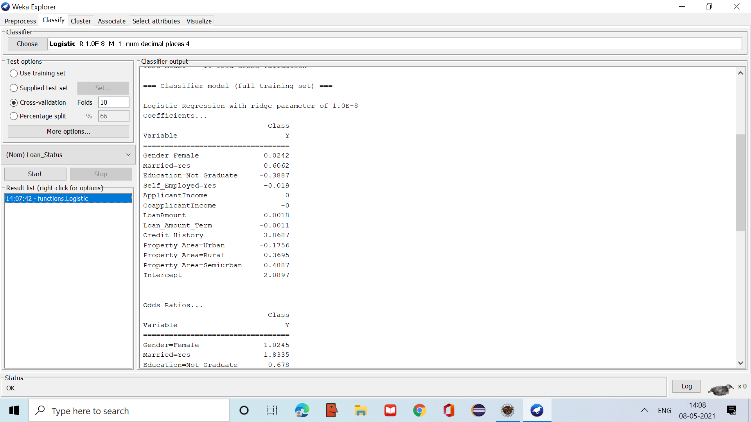

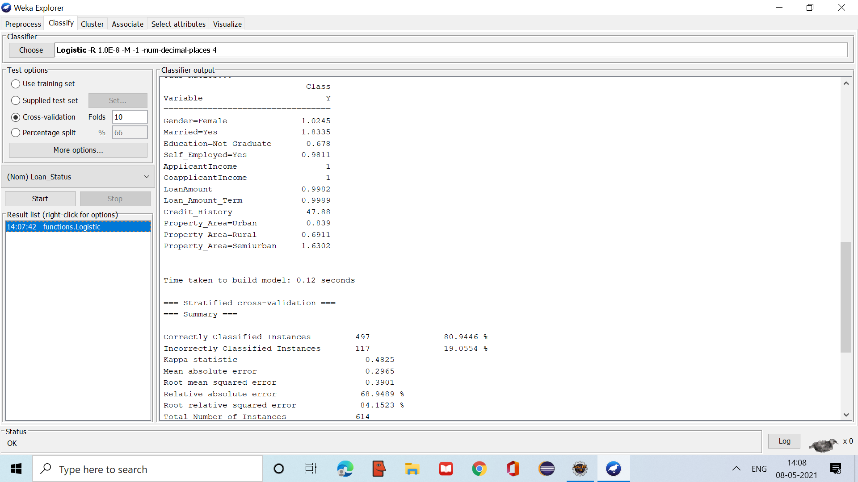

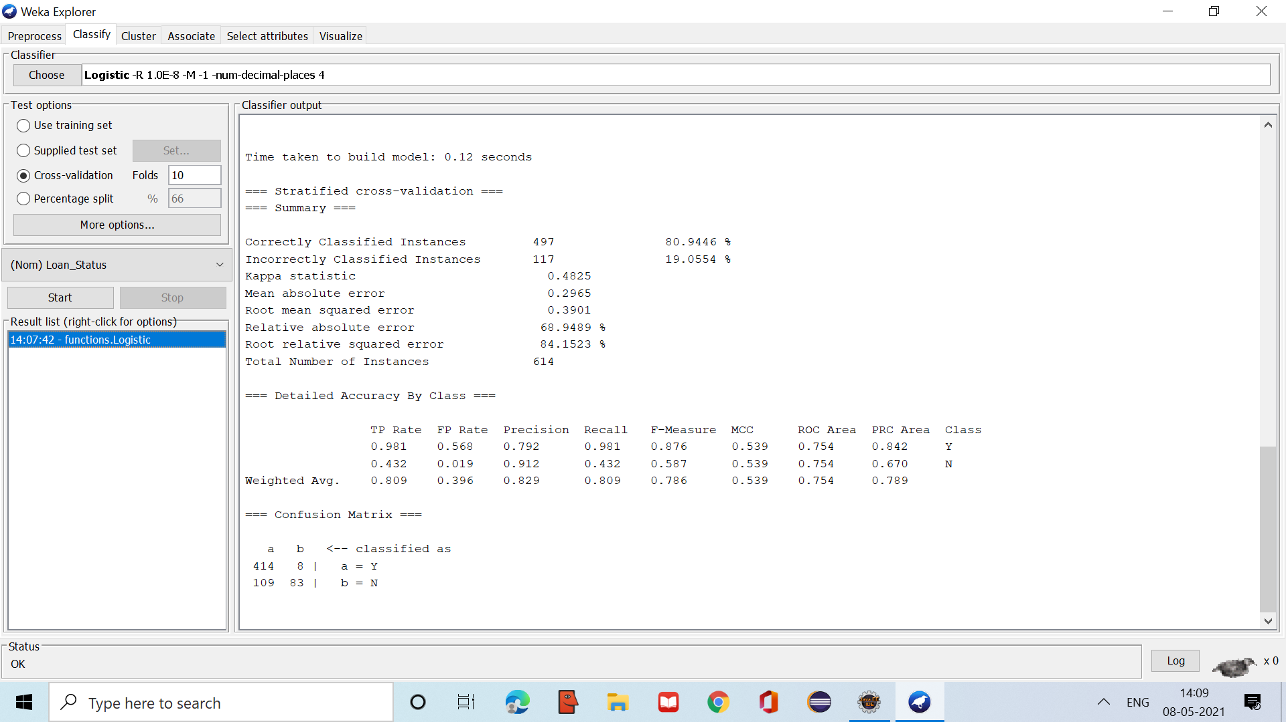

APPLICATIONS:

* Applicable to find whether a customer of bank can get loan or not based on details of the Applicant.
* Helpful to bank for validating whether the applicant will repay the amount .

CONCLUSION:

* Goal of this project is to automate the loan eligibility process (real time) based on customer detail provided while filling online application form.
* The main aim of this use-case is to build a predictive model to predict if an applicant is able to repay the lending company or not.
* Here using logistic regression we built the prediction model and from we have evaluated the testing data with good accuracy.